LEARNLOOP: PEER-TO-PEER KNOWLEDGE EXCHANGE PLATFORM WITH INTEGRATED REAL-TIME VIDEO COLLABORATION
A PROJECT REPORT
Submitted in partial fulfillment of the requirements for the award of the degree of
BACHELOR OF TECHNOLOGY
in
COMPUTER SCIENCE AND ENGINEERING
UNDER THE ESTEEMED GUIDANCE OF
Y. Karuna Manjusha (M.TECH)
Assistant Professor, Dept. of CSE
SUBMITTED BY
G. ABHISHEK (25HP5A0517)
N. DHEERAJ (25HP5A0518)
CH. SACHIN MANIKANTA (25HP5A0519)
B. VIJAY KUMAR (25HP5A0520)
N. VINAY KUMAR (24HP1A05J5)
V. PRASAD (24HP1A05J6)

DEPARTMENT OF COMPUTER SCIENCE AND ENGINEERING
ANDHRA LOYOLA INSTITUTE OF ENGINEERING AND TECHNOLOGY
(AFFILIATED TO JNTU KAKINADA) VIJAYAWADA.
2026-2027

ANDHRA LOYOLA INSTITUTE OF ENGINEERING AND TECHNOLOGY
(AFFILIATED TO JNTU KAKINADA) VIJAYAWADA - 520008
DEPARTMENT OF COMPUTER SCIENCE AND ENGINEERING
DEPARTMENT VISION, MISSION, PSOs & PEOs
Department Vision
To equip the students with adequate technical knowledge that promotes them to contribute their expertise in the arena of academics, industry and society.
Department Mission
M1: To produce the best quality computer science professionals through intellectual inputs.
M2: To impart quality training, hands on experience and value education to solve the real world problems.
M3: To provide an environment that values and encourages knowledge acquisition.
Program Specific Outcomes (PSOs)
PSO1: Able to develop code on multiple platforms meeting the needs of IT industry.
PSO2: Able to analyze & apply the optimization techniques for the enhancement of application.
Program Educational Objectives (PEOs)
PEO1: To make them apply their computer science knowledge and problem solving skills to be successful computer professionals in diverse career paths including supportive and leadership roles on multidisciplinary teams.
PEO2: To make graduates change their ability to master the latest areas of computer science.
PEO3: Ability to design and develop software applications to meet societal needs.

ANDHRA LOYOLA INSTITUTE OF ENGINEERING AND TECHNOLOGY
VIJAYAWADA - 520008
DEPARTMENT OF COMPUTER SCIENCE AND ENGINEERING
CERTIFICATE
This is to certify that the project report entitled “LEARNLOOP: PEER-TO-PEER KNOWLEDGE EXCHANGE PLATFORM WITH INTEGRATED REAL-TIME VIDEO COLLABORATION” submitted by G. ABHISHEK (25HP5A0517), N. DHEERAJ (25HP5A0518), CH. SACHIN MANIKANTA (25HP5A0519), B. VIJAY KUMAR (25HP5A0520), N. VINAY KUMAR (24HP1A05J5), V. PRASAD (24HP1A05J6) in partial fulfillment of the requirements for the award of the degree of Bachelor of Technology in Computer Science and Engineering is a bonafide work carried out by them under my supervision during the academic year 2026-2027.
The results embodied in this report have not been submitted to any other University or Institute for the award of any degree or diploma.
(Y. Karuna Manjusha (M.TECH)) | (Dr. L. Kanya Kumari)
Assistant Professor | Head of The Department
Dept. of CSE | Dept. of CSE
Signature of the External Examiner: _______________________
Date: _______________________

DECLARATION
We, G. ABHISHEK (25HP5A0517), N. DHEERAJ (25HP5A0518), CH. SACHIN MANIKANTA (25HP5A0519), B. VIJAY KUMAR (25HP5A0520), N. VINAY KUMAR (24HP1A05J5), V. PRASAD (24HP1A05J6), hereby declare that the project entitled “LEARNLOOP: PEER-TO-PEER KNOWLEDGE EXCHANGE PLATFORM WITH INTEGRATED REAL-TIME VIDEO COLLABORATION” is a record of original work done by us under the guidance of Y. Karuna Manjusha (M.TECH), Assistant Professor, Department of Computer Science and Engineering, Andhra Loyola Institute of Engineering and Technology, Vijayawada.
We further declare that the work reported herein has not been submitted either in part or in full for the award of any other degree or diploma in this institute or any other university.
Roll No. | Name of the Student | Signature
25HP5A0517 | G. ABHISHEK | ____________________
25HP5A0518 | N. DHEERAJ | ____________________
25HP5A0519 | CH. SACHIN MANIKANTA | ____________________
25HP5A0520 | B. VIJAY KUMAR | ____________________
24HP1A05J5 | N. VINAY KUMAR | ____________________
24HP1A05J6 | V. PRASAD | ____________________

ACKNOWLEDGEMENT
We express our deep sense of gratitude to our respected Director Rev. Fr. Dr. Antonysamy and Principal Dr. O. Mahesh for providing necessary infrastructure and academic environment which paved the way for successful completion of our project.
We convey our heartfelt thanks to Dr. L. Kanya Kumari, Head of the Department, Computer Science and Engineering, for her continuous support, timely encouragement, and valuable advice throughout the progress of our curriculum.
We place on record our sincere gratitude to our esteemed guide Y. Karuna Manjusha (M.TECH), Assistant Professor, Department of Computer Science and Engineering, for her invaluable guidance, patient mentoring, constructive critique, and insightful suggestions which enabled us to overcome challenges during the design and deployment of this platform.
We also extend our earnest appreciation to all the teaching and non-teaching faculty members of the Department of Computer Science and Engineering for their direct and indirect cooperation.
Finally, we express our profound gratitude to our parents, family members, and friends for their steadfast encouragement, moral support, and blessings throughout our academic journey.
PROJECT ASSOCIATES:
G. ABHISHEK (25HP5A0517)
N. DHEERAJ (25HP5A0518)
CH. SACHIN MANIKANTA (25HP5A0519)
B. VIJAY KUMAR (25HP5A0520)
N. VINAY KUMAR (24HP1A05J5)
V. PRASAD (24HP1A05J6)

ABSTRACT
In the modern knowledge-driven era, learning is often hindered by financial barriers, rigid curricular structures, and a lack of personalized one-on-one mentorship. Commercial educational platforms charge high hourly rates or rely solely on passive pre-recorded lecture videos, eliminating reciprocal interactive engagement. To resolve these limitations, this project presents LearnLoop, an innovative full-stack peer-to-peer (P2P) knowledge exchange platform based on a currency-free barter economy.
LearnLoop enables individuals to exchange skills symmetrically—offering personal expertise (e.g., Python, Graphic Design, Web Development) in return for skills they wish to acquire (e.g., UI/UX, Public Speaking, Data Science). The platform incorporates secure authentication via Google OAuth 2.0 and JWT credentials, intelligent keyword and category-based peer discovery, a formal swap proposal state machine (Pending, Accepted, Rejected, Completed), and integrated bidirectional real-time text messaging powered by Socket.IO.
Crucially, to facilitate immediate interactive learning sessions, LearnLoop features an embedded WebRTC (Web Real-Time Communication) audio/video collaboration room complete with peer-to-peer media streaming, camera/microphone toggling, full-screen switching, and synchronized collaborative note-taking. Built on a modular React single-page frontend and a resilient Node.js/Express backend with dual persistence architecture (MongoDB and High-Performance JSON Store), the system delivers ultra-low latency, zero third-party licensing dependencies, and high accessibility across modern desktop and mobile web browsers.

CONTENTS
Title |  | Page No
DEPARTMENT VISION, MISSION, PSOs & PEOs |  | i
CERTIFICATE |  | ii
DECLARATION |  | iii
ACKNOWLEDGEMENT |  | iv
ABSTRACT |  | v
CHAPTER 1 | INTRODUCTION | 1
 | 1.1 Basic Concepts | 1
 | 1.2 Motivation | 2
 | 1.3 Problem Statement | 2
CHAPTER 2 | LITERATURE SURVEY | 3
CHAPTER 3 | SYSTEM ANALYSIS | 4
 | 3.1 Project SDLC (Agile & Iterative Methodology) | 4
 | 3.2 Functional Requirements | 6
 | 3.3 Non-Functional Requirements | 7
 | 3.4 System Requirements (Software & Hardware) | 8
CHAPTER 4 | RELATED WORK | 9
 | 4.1 Existing System & Disadvantages | 9
 | 4.2 Proposed System & Advantages | 10
CHAPTER 5 | SOFTWARE DESIGN (UML SPECIFICATIONS) | 12
 | 5.1 Use Case Specifications | 12
 | 5.2 Class Model & Entity Specifications | 14
 | 5.3 Sequence Signaling Flow | 16

CONTENTS (CONTINUED)
Title |  | Page No
 | 5.4 Collaboration & Message Interaction | 18
 | 5.5 Activity Workflow | 19
 | 5.6 State Transition Lifecycle | 20
 | 5.7 Component Architecture | 21
 | 5.8 Cloud Deployment Topology | 22
CHAPTER 6 | IMPLEMENTATION | 23
 | 6.1 System Architecture | 23
 | 6.2 Methodology & Workflow | 24
 | 6.3 Platform Modules Description | 25
 | 6.4 Technology Stack & Database Schemas | 27
CHAPTER 7 | CODING | 30
 | 7.1 Frontend Architecture & Core Implementation | 30
 | 7.2 Backend RESTful API & Socket Signaling Engine | 37
CHAPTER 8 | TEST CASES & OPERATIONAL SCREENS | 44
 | 8.1 Testing Methodologies & Objectives | 44
 | 8.2 Levels of Testing | 45
 | 8.3 Comprehensive Test Cases Table | 46
 | 8.4 User Interface & Operational Screens | 49
CHAPTER 9 | CONCLUSION | 55
CHAPTER 10 | FUTURE SCOPE | 56
CHAPTER 11 | BIBLIOGRAPHY | 57
LIST OF FIGURES & TABLES |  | 58

LIST OF FIGURES & TABLES
Item No | Title / Caption | Page No
Table 2.1 | Comparison of LearnLoop with Contemporary Learning Frameworks | 3
Table 5.1 | Formal Use Case Actors and Operational Actions | 13
Table 5.2 | System Entity Attributes, Constraints, and Operations | 15
Table 5.3 | State Machine Transition Matrix for Swap Requests | 20
Table 6.1 | User Entity Database Schema Definition | 28
Table 6.2 | SwapRequest Entity Database Schema Definition | 29
Table 8.1 | Comprehensive Software Verification and Test Matrix | 46
Fig. 8.1 | Application Home Page & Hero Navigation Interface | 49
Fig. 8.2 | Peer Discovery & Skill Marketplace Filtering Screen | 50
Fig. 8.3 | Swap Proposal Management & Negotiation Dashboard | 51
Fig. 8.4 | Real-Time Direct Messaging Interface with Profile Inspection | 52
Fig. 8.5 | WebRTC Peer-to-Peer Interactive Video Collaboration Room | 53

CHAPTER 1
INTRODUCTION
1.1 BASIC CONCEPTS
Skill acquisition is the foundational pillar of modern human capital development. However, rapid advancements in technology, creative disciplines, and professional domains demand agile, continuous, and highly individualized learning paradigms. Traditional educational structures—including universities, vocational academies, and commercial certification portals—exhibit substantial rigidity, prohibitive financial expenses, and sluggish adaptation to emerging market demands. While millions of people across the globe possess deep practical proficiencies in diverse skills such as programming, musical composition, foreign languages, graphic design, and culinary arts, they lack a dedicated medium to reciprocally leverage their skills.
LearnLoop introduces a decentralized, peer-to-peer (P2P) knowledge exchange paradigm rooted in the economic principles of reciprocal bartering. Rather than requiring monetary payments, subscriptions, or credit card authorizations, LearnLoop establishes a bilateral knowledge transfer marketplace. A participant who is proficient in Web Development and eager to learn Spanish can seamlessly connect with a native Spanish speaker wanting to build a web portfolio. By treating human knowledge as a shared, liquid, non-monetary currency, LearnLoop transforms individual users into simultaneous educators and apprentices, breaking down economic barriers to lifelong learning.
1.2 MOTIVATION
The motivation behind engineering LearnLoop stems from observing key deficiencies in contemporary online educational ecosystems:
1. Economic Inequity in Mentorship: One-on-one expert tutoring and mentorship typically charge steep rates ranging from $40 to $150 per hour. This restricts tailored guidance exclusively to individuals with substantial disposable income, leaving underrepresented students and self-learners at an acute disadvantage.
2. Isolation of Asynchronous Content: Standard Massive Open Online Courses (MOOCs) suffer from completion rates below 10%. Asynchronous, pre-recorded video lectures lack the interpersonal accountability, spontaneous clarification, and direct peer encouragement inherent in live human interaction.
3. Fragmentation of Learning Tools: Existing online communities force users to patch together disparate third-party applications—utilizing Reddit or Discord for discovery, Google Docs for notes, WhatsApp for scheduling, and Zoom or Google Meet for video calls. This fragmentation induces friction, dropped connections, and severe communication fatigue.
4. Need for a Unified, Zero-Friction Web Architecture: By combining discovery, scheduling, instant messaging, synchronized collaborative note-taking, and peer-to-peer WebRTC video streaming into a single, cohesive web platform, LearnLoop delivers an effortless, immediate learning environment accessible straight from any modern browser.
1.3 PROBLEM STATEMENT
To conceptualize, architect, and deploy a secure, highly scalable, and user-friendly Peer-to-Peer Knowledge Exchange Web Platform (LearnLoop) that facilitates direct skill barter transactions. The platform must eliminate financial mediation, provide frictionless user discovery through multi-attribute matching, orchestrate swap negotiations via a formal request state machine, supply real-time socket-driven messaging, and host low-latency in-browser WebRTC video collaboration rooms without requiring external software installations or expensive commercial infrastructure.

CHAPTER 2
LITERATURE SURVEY
A focused survey in collaborative computing, peer-to-peer learning networks, and real-time communication architectures was conducted to ground the design of LearnLoop:
1. Collaborative Peer-to-Peer Learning (Boud et al., 2014): Reciprocal peer learning accelerates cognitive retention by encouraging learners to articulate ideas, diagnose misconceptions, and engage in active meta-cognition through structured bilateral commitments.
2. Barter Economics and Non-Monetary Digital Systems (Anderson, 2018): Modern digital platforms eliminate monetary friction through skill bartering, addressing the double coincidence of wants with dynamic search indexing and multi-category interest matching.
3. Web Real-Time Communication Protocols (Loreto et al., 2012; RFC 7478): WebRTC enables browser-to-browser media streaming with sub-500ms latency, SRTP encryption, and adaptive bitrate control via STUN/TURN NAT traversal.
4. WebSocket Signaling and State Synchronization (Fette & Melnikov, 2011; RFC 6455): Full-duplex WebSocket connections facilitate instantaneous push notifications for swap requests, live chat, and WebRTC SDP offer/answer exchanges.
Table 2.1 summarizes the architectural and operational contrast between LearnLoop and prevailing market platforms:
Feature / Dimension | Commercial EdTech  (Coursera / Udemy) | Private Mentoring  (Preply / Wyzant) | LearnLoop  (Proposed System)
Cost Model | Paid Subscriptions / Pay per course | High Hourly Fees ($30-$100/hr) | 100% Free / Skill Barter
Pedagogy | Passive / Pre-recorded | Active / 1-on-1 | Reciprocal Active 1-on-1
Communication | Discussion Forum / Asynchronous | Third-party Zoom / Skype | Embedded WebRTC P2P Video
Live Collaboration | None / Static PDFs | External Tools | Integrated Collaborative Notes
Authentication | Email / Password Walls | Custom Proprietary Sign-in | Frictionless Google OAuth 2.0
Hosting Overhead | Massive CDN / Video Servers | Centralized Servers | Low-Cost Static / Mesh P2P
Table 2.1: Comparison of LearnLoop with Contemporary Learning Frameworks

CHAPTER 3
SYSTEM ANALYSIS
3.1 PROJECT SDLC (AGILE & ITERATIVE METHODOLOGY)
The development of LearnLoop adhered to an Agile-Iterative Life Cycle Model. Due to the interdependent nature of real-time WebRTC media streams, socket signaling, and responsive user interfaces, an agile incremental approach provided rapid feedback cycles, empirical validation, and modular refinement across six key phases:
Phase 1: Planning and Requirement Analysis: Conducted domain research to analyze peer barter dynamics, security considerations (OAuth vs JWT), and media transport protocols. Formulated user stories and technical feasibility matrices.
Phase 2: Defining Requirements: Authored comprehensive Software Requirement Specifications (SRS) covering functional endpoints, non-functional latency benchmarks, and data schemas.
Phase 3: Designing the Software: Modeled system behaviors using structured specifications for Use Cases, Classes, Sequence signaling, Activity workflows, Component interactions, and Cloud deployment.
Phase 4: Developing the Project: Constructed the core system through iterative sprints: Sprint 1 (Auth & Profile Engine), Sprint 2 (Discovery & Swap Proposal Machine), Sprint 3 (Socket.IO Messaging), Sprint 4 (WebRTC Media Room & Collaborative Notes).
Phase 5: Testing: Conducted thorough unit testing, component integration verification, WebRTC ICE connection diagnostics, and end-to-end responsive UI testing across browsers.
Phase 6: Deployment & Maintenance: Automated cloud deployment utilizing Render for the containerized Node.js backend and Netlify for the static React single-page frontend with CDN caching.
3.2 FUNCTIONAL REQUIREMENTS
FR-01: Authentication & Authorization: Users must authenticate via secure Google OAuth 2.0 or local credential verification. Successful login must issue a cryptographically signed JSON Web Token (JWT) authorizing subsequent protected API requests.
FR-02: Profile & Skill Portfolio Management: Users must manage a rich profile specifying their bio, occupation, avatar, skills offered (with proficiency levels), and skills desired.
FR-03: Peer Discovery & Filtering: The platform must provide real-time search indexing and category filtering allowing users to discover compatible peers by skill keyword or skill category.
FR-04: Swap Proposal State Machine: Users can transmit formal swap requests proposing an offered skill in exchange for a target skill. The recipient can accept or reject the proposal with automatic status synchronization.
FR-05: Real-Time Direct Messaging: Peers with active engagements can exchange real-time text messages with instant socket delivery and persistent message history.
FR-06: WebRTC Audio/Video Meeting Room: Users can launch dedicated, secure peer-to-peer video rooms featuring low-latency audio/video feeds, mic/camera controls, full-screen mode, and shared collaborative notes.
FR-07: Community Trust & Review Engine: Upon completion of learning sessions, peers can rate each other (1-5 stars) and publish qualitative reviews to establish platform reputation.
3.3 NON-FUNCTIONAL REQUIREMENTS
NFR-01: Performance & Low Latency: REST API response times must remain under 200ms under standard loads. WebRTC audio/video transmission latency must remain below 400ms across typical broadband connections.
NFR-02: Scalability: The backend architecture must support horizontal scaling with stateless REST controllers and lightweight socket connection registries.
NFR-03: Security & Data Privacy: Passwords must be hashed using salted bcrypt algorithms. Media channels must enforce DTLS-SRTP encryption in accordance with WebRTC standards.
NFR-04: Usability & Cross-Platform Accessibility: The web interface must be fully responsive, rendering flawlessly on mobile viewports (360px+), tablets, and high-resolution desktop displays without layout degradation.
NFR-05: Reliability & Graceful Degradation: If MongoDB encounters connection timeouts, the backend must automatically engage its internal JSON memory fallback store to ensure 100% platform uptime.
3.4 SYSTEM REQUIREMENTS (SOFTWARE & HARDWARE)
The technical specifications required to execute and run LearnLoop are detailed below:
Software Specifications:
• Operating System: Windows 10/11, macOS Monterey+, or Ubuntu Linux 20.04+
• Runtime Environment: Node.js (v18.x or v20.x LTS)
• Frontend Framework: React 18, Vite 5, Modern CSS3 Flexbox/Grid
• Backend Framework: Express 4.x, Socket.IO 4.x
• Database: MongoDB / Mongoose with High-Performance JSON Memory Fallback Engine
• Supported Web Browsers: Google Chrome (v100+), Mozilla Firefox (v100+), Microsoft Edge (v100+)
• Version Control: Git & GitHub
Hardware Specifications:
• Processor: Intel Core i5/i7 (8th Gen or above) / AMD Ryzen 5/7 series
• Random Access Memory (RAM): 8 GB minimum (16 GB recommended)
• Persistent Storage: 256 GB Solid State Drive (SSD)
• Peripherals: Integrated or external HD Webcam, Microphone, and Audio Output
• Network: Broadband Internet with minimum 10 Mbps upstream/downstream bandwidth

CHAPTER 4
RELATED WORK
4.1 EXISTING SYSTEM & DISADVANTAGES
Contemporary educational systems primarily follow two models: centralized course marketplaces (such as Udemy, Coursera, and edX) and private hourly tutor platforms (such as Preply, Wyzant, and Cambly).
In course marketplaces, content delivery is completely unidirectional. Instructors produce pre-recorded video sequences which students consume passively. When learners confront ambiguities or require conceptual troubleshooting, their only recourse is posting in public discussion boards that rarely receive timely or personalized answers.
In private tutoring marketplaces, the interaction is live and interactive, but it is gated behind expensive financial paywalls. Platform commissions typically deduct 20% to 33% of the tutor's earnings, while charging students exorbitant hourly rates. Furthermore, these platforms lack integrated collaboration environments, relying on users to coordinate across external software suites (Skype, Zoom, Google Drive), creating cognitive friction.
Disadvantages of the Existing System:
1. Severe Financial Exclusion: Quality one-on-one mentorship is inaccessible to socio-economically disadvantaged learners who cannot afford recurring hourly tutoring fees.
2. Passive Learning Deficit: Pre-recorded lectures cannot evaluate a student's live coding, pronunciation, or design technique in real-time, resulting in high dropout rates.
3. Monolithic Commercial Lock-in: Users have no autonomy over the economic exchange; tutors must accept platform price caps and delayed payout schedules.
4. Fragmented Tooling Ecosystem: Users waste considerable time managing disjointed apps for communication, scheduling, document sharing, and video calling.
4.2 PROPOSED SYSTEM & ADVANTAGES
LearnLoop presents a paradigm shift by implementing a direct peer-to-peer barter platform where time and knowledge are traded symmetrically without any financial intermediary. The system enables users to create detailed profiles listing their pedagogical assets (skills they can teach) alongside their developmental objectives (skills they wish to learn).
An intelligent indexing engine matches complementary users, enabling them to initiate formal swap proposals. Upon bilateral agreement, the platform provisions a private communication room complete with low-latency WebRTC video conferencing, bidirectional text messaging, and live collaborative note-taking.
Advantages of the Proposed System:
1. Democratized Access (Zero Financial Barrier): Any motivated individual with a valuable skill can learn another high-demand skill entirely for free through reciprocal barter.
2. Active, High-Retention Pedagogy: Direct one-on-one video interaction ensures active dialogue, immediate feedback, and personal accountability.
3. All-in-One Unified Web Architecture: Discovery, negotiation, messaging, collaborative notes, and video meetings take place seamlessly inside the web browser with zero external installations.
4. Resilient & Low-Cost Infrastructure: By leveraging WebRTC mesh streaming, peer media flows directly between user devices without routing through costly central video servers, enabling sustainable hosting on modest infrastructure.

CHAPTER 5
SOFTWARE DESIGN (FORMAL UML SPECIFICATIONS)
Software design translates abstract domain requirements into structured computational entities. In this chapter, system interactions, architectural classes, sequence lifecycles, and component topographies are specified using formal, rigorous UML tabular definitions without informal textual sketches.
5.1 USE CASE SPECIFICATIONS
The Use Case model articulates interactions across the four primary actors: Guest User, Registered Member, Remote Peer Collaborator, and Authentication Identity Provider.
Actor | Use Case | Description | Preconditions | Postconditions
Guest User | Browse Catalog | Explore skills and user profiles without credentials | None | Display catalog
Guest User | Authenticate | Login via Google OAuth 2.0 or local credentials | Network connectivity | JWT issued, dashboard loaded
Registered Member | Update Portfolio | Declare skills offered, mastery level, bio, and targets | Active session | Profile persisted in database
Registered Member | Initiate Swap | Dispatch formal proposal offering Skill A for Skill B | Profile created | Request stored with status 'pending'
Recipient Peer | Evaluate Swap | Accept or decline pending proposal from peer | Received request | State transitions to 'accepted'/'rejected'
Both Peers | Real-Time Chat | Exchange instant text messages via Socket.IO | Active swap connection | Message delivered and logged
Both Peers | WebRTC Video Meeting | Join P2P mesh audio/video call with live notes | Swap accepted | Real-time media streaming active
Both Peers | Submit Review | Submit 1-5 star rating and feedback on session | Session concluded | Rolling rating recalculated
Table 5.1: Formal Use Case Actors and Operational Actions
5.2 CLASS MODEL & ENTITY SPECIFICATIONS
The class model formalizes object-oriented entities, encapsulation boundaries, relationships, and operational methods across the system:
Class Name | Key Attributes | Associated Methods | Multiplicity & Relationships
User | id, name, email, avatar, bio, skillsOffered[], skillsDesired[], rating, reviewCount | getProfile(), updateSkills(), recalculateRating() | 1 to Many with SwapRequest (as sender/receiver); 1 to Many with Message
SwapRequest | id, senderId, receiverId, offeredSkill, requestedSkill, status, note, createdAt | accept(), reject(), complete(), cancel() | Many to 1 with User (Sender); Many to 1 with User (Receiver)
Message | id, senderId, receiverId, text, timestamp, isRead | send(), markAsRead(), getHistory() | Many to 1 with User
VideoRoom | roomId, participants[], sharedNotes, isActive, createdAt | handleOffer(), handleAnswer(), handleIce(), syncNotes() | 1 to 1 with accepted SwapRequest
Review | id, authorId, targetId, rating, comment, createdAt | submit(), validate() | Many to 1 with User (Target)
Table 5.2: System Entity Attributes, Constraints, and Operations
5.3 SEQUENCE SIGNALING FLOW
The chronological sequence of operations governing WebRTC call establishment proceeds through nine structured steps:
1. Join Notification: Peer A dispatches join-room with the unique room identifier to the Socket.IO signaling server.
2. Peer Connection: Peer B joins the same room; the signaling server emits user-connected to Peer A.
3. Local Media Acquisition: Both peers call navigator.mediaDevices.getUserMedia() to capture local audio/video streams.
4. Offer Generation: Peer A constructs an RTCPeerConnection, adds local media tracks, calls createOffer(), sets localDescription, and emits offer to the signaling server.
5. Offer Relay: The signaling server forwards the Session Description Protocol (SDP) offer payload to Peer B.
6. Answer Generation: Peer B sets remoteDescription with Peer A's offer, creates an SDP answer via createAnswer(), sets localDescription, and emits answer back to the server.
7. Answer Relay: The server delivers Peer B's answer to Peer A, which completes remote configuration via setRemoteDescription().
8. ICE Candidate Exchange: Both peers asynchronously gather Interactive Connectivity Establishment (ICE) candidates via STUN (stun.l.google.com:19302) and exchange them through the socket.
9. Media Streaming: The direct peer-to-peer encrypted SRTP media pipeline opens, rendering live video feeds and enabling bidirectional notes synchronization.
5.4 COLLABORATION & MESSAGE INTERACTION
The collaboration architecture models real-time messaging between participants:
• Direct Message Dispatch: A user emits send-message with receiverId and text payload.
• Persistence Validation: The backend message controller persists the payload to the storage layer with a timestamp.
• Socket Routing: If the recipient socket is registered in the active client dictionary, the payload is pushed immediately via receive-message; otherwise, it awaits client retrieval upon subsequent inbox polling.
• Unread Badge Notification: The client updates its badge counter and allows one-click profile inspection directly from the conversation header.
5.5 ACTIVITY WORKFLOW
The activity workflow encompasses the complete end-to-end user journey across nine sequential stages:
1. Start: User navigates to the LearnLoop web URL.
2. Authentication Decision: If logged in, proceed to Dashboard; otherwise, complete Google OAuth authentication.
3. Skill Portfolio Management: User configures skills offered and skills desired.
4. Peer Search: User filters marketplace by keywords (e.g., Python, Photoshop, Spanish).
5. Request Formulation: User clicks 'Request Swap' on a matched profile and submits proposal details.
6. Recipient Decision Branch: Recipient reviews the request in their Requests dashboard. If declined, the status becomes 'rejected' and flow terminates. If accepted, status becomes 'accepted'.
7. Interactive Collaboration: Both peers enter the provisioned /room/:roomId for live WebRTC audio/video learning.
8. Session Evaluation: Upon call completion, peers submit mutual star ratings and qualitative reviews.
9. End: System updates rolling reputation averages.
5.6 STATE CHART LIFECYCLE
A swap request strictly transitions across four discrete states without ambiguity:
Current State | Triggering Event | Guard Condition | Next State | System Actions
None | User submits swap proposal | User authenticated & target != self | PENDING | Persist request; emit socket notification to recipient
PENDING | Recipient clicks 'Accept' | Session active & user == receiverId | ACCEPTED | Update status; generate unique video room link
PENDING | Recipient clicks 'Decline' | Session active & user == receiverId | REJECTED | Update status; notify sender
ACCEPTED | Peers join video meeting room | Room URL accessed by participants | IN_PROGRESS | Establish WebRTC media stream & collaborative notes
IN_PROGRESS | Call terminated & review posted | Call ended | COMPLETED | Close room; prompt mutual feedback & persist ratings
Table 5.3: State Machine Transition Matrix for Swap Requests
5.7 COMPONENT ARCHITECTURE
The physical software organization is partitioned into modular components:
• Client Components: React Single-Page Architecture comprising AuthModal, Navbar, PeerCard, SkillFilter, SwapDashboard, ChatPanel, and WebRTCVideoRoom.
• Communication Bridge: Axios for asynchronous REST JSON transport; Socket.IO Client for real-time WebSocket messaging and media negotiation events.
• Backend Controllers: AuthController (OAuth token verification), RequestController (Swap state machine), MessageController (Chat dispatch), and SignalingGateway (Socket.IO event routing).
• Storage Adapters: Dual persistence engine featuring a Mongoose ODM adapter for MongoDB clusters and a synchronized JSON filesystem adapter for local development and failover resilience.
5.8 CLOUD DEPLOYMENT TOPOLOGY
LearnLoop is deployed across professional cloud computing infrastructure:
• Frontend Hosting (Netlify): Built via Vite 5 (npm run build), producing optimized HTML5/CSS3/JS assets distributed globally over Netlify's high-speed Content Delivery Network (CDN) edge nodes with automatic HTTPS and URL rewrites (_redirects).
• Backend Hosting (Render): Containerized Node.js service executed on Render cloud nodes (npm start), exposing secure HTTPS and WSS endpoints for REST API routing and persistent WebSocket signaling.
• Peer-to-Peer Media Transit: WebRTC audio/video packets stream directly between user client devices across SRTP media pipelines, using Google's public STUN servers for NAT traversal, eliminating server bandwidth bottlenecks.

CHAPTER 6
IMPLEMENTATION
6.1 SYSTEM ARCHITECTURE
LearnLoop adopts a decoupled, modern three-tier client-server architecture engineered for high concurrency, zero licensing cost, and rapid client responsiveness. The architecture separates presentation, business logic, and persistence into distinct layers:
1. Presentation Layer (Client): Engineered in React 18 utilizing the Vite 5 build toolchain. Provides dynamic single-page application (SPA) routing, responsive layout rendering, local media capture (navigator.mediaDevices.getUserMedia), and WebRTC audio/video canvas projection.
2. Application & Signaling Layer (Backend): Powered by Node.js and Express 4.x. Implements stateless RESTful endpoints for CRUD operations and a persistent Socket.IO server that coordinates WebRTC signaling (SDP offer/answer exchange, ICE candidates), real-time chat, and live collaborative note broadcasting.
3. Persistence Layer: Features a resilient dual-mode database engine. In production environments with active database clusters, it integrates with MongoDB via Mongoose. If a local or remote MongoDB instance is unreachable, it seamlessly switches to an embedded high-performance asynchronous JSON data store (data/store.json), preventing service interruptions.
6.2 METHODOLOGY & WORKFLOW
The operational lifecycle of a skill exchange on LearnLoop proceeds through four distinct stages:
Stage 1: Profile Initialization & Skill Mapping: The user authenticates and enters their personal skills portfolio. The user categorizes their expertise under recognized disciplines (Development, Design, Language, Music, Business, Academics) and indicates their level (Beginner, Intermediate, Expert), followed by skills they desire to learn.
Stage 2: Discovery and Algorithmic Filtering: The exploration engine searches the user registry, applying multi-parameter substring matching across names, bio descriptions, and offered/desired skill tags. Users can browse full profiles, review historical 5-star ratings, and evaluate reciprocal compatibility.
Stage 3: Proposal Negotiation & Socket Messaging: A user initiates a swap request specifying what they offer in exchange. The recipient receives an instant push alert. Both users can communicate via instant messaging to schedule a meeting time, ask clarifying questions, and agree on an agenda.
Stage 4: Interactive WebRTC Video Session & Note Collaboration: Upon agreement, users join a dedicated meeting room. The browser captures local video/audio, transmits an SDP offer through the signaling server, establishes a peer-to-peer connection via STUN, and streams low-latency media. Concurrently, a shared notes workspace synchronizes text edits across participants using delta-socket events.
6.3 PLATFORM MODULES DESCRIPTION
Module 1 - Authentication & Security: Manages user identification via Google OAuth 2.0 Identity Services (@react-oauth/google) and local JWT tokens. Implements secure token generation, validation middleware, and protected API routes.
Module 2 - User & Skill Portfolio Engine: Enables users to manage personal data, upload profile avatars, declare skills offered with mastery tags, and list desired learning goals.
Module 3 - Search & Filtering Engine: Executes dynamic client-side and server-side filtering by skill name, user name, and category keywords with instantaneous UI updates.
Module 4 - Swap Proposal State Machine: Enforces strict lifecycle integrity across swap requests (pending -> accepted | rejected -> completed). Prevents duplicate proposals and enables one-click cancellations.
Module 5 - Real-Time Socket Messaging: Coordinates persistent bidirectional messaging between peers, delivering unread notifications, message timestamps, and deep profile view navigation from within chat.
Module 6 - WebRTC Audio/Video & Note Collaboration Room: Facilitates full-duplex peer-to-peer video streaming, camera/mic toggling, screen maximization, and live collaborative scratchpad synchronization.
Module 7 - Ratings & Review Subsystem: Calculates user reputation metrics based on post-session reviews, calculating rolling arithmetic averages displayed prominently on user discovery cards.
6.4 TECHNOLOGY STACK & DATABASE SCHEMAS
The relational schemas defining data entities in LearnLoop are structured as follows:
Field Name | Data Type | Constraints | Description
_id / id | String / ObjectId | Primary Key, Unique | Unique user identifier
name | String | Required | Full name of the user
email | String | Required, Unique | User email address
avatar | String | Optional | URL to avatar image
bio | String | Optional | Short personal biography
skillsOffered | Array of Objects | Required | Array of { name, category, level }
skillsDesired | Array of Objects | Required | Array of { name, category }
rating | Number | Default: 5.0 | Rolling average star rating
reviewCount | Number | Default: 0 | Total number of reviews received
createdAt | Date | Default: Date.now | Account creation timestamp
Table 6.1: User Entity Schema Definition
Field Name | Data Type | Constraints | Description
_id / id | String / ObjectId | Primary Key, Unique | Unique swap proposal identifier
senderId | String | Foreign Key (User) | ID of user initiating the proposal
receiverId | String | Foreign Key (User) | ID of targeted recipient peer
offeredSkill | String | Required | Skill name offered by sender
requestedSkill | String | Required | Skill requested from recipient
note | String | Optional | Introductory proposal message
createdAt | Date | Default: Date.now | Proposal timestamp
Table 6.2: SwapRequest Entity Schema Definition

CHAPTER 7
CODING
This chapter presents essential code listings from both the frontend and backend architectures of the LearnLoop platform, demonstrating the implementation of Google OAuth, WebRTC video calling, Socket.IO signaling, and swap lifecycle management.
7.1 FRONTEND IMPLEMENTATION
7.1.1 Google Authentication Provider Integration (frontend/src/main.jsx):
import React from 'react';
import ReactDOM from 'react-dom/client';
import { BrowserRouter } from 'react-router-dom';
import { GoogleOAuthProvider } from '@react-oauth/google';
import App from './App';
import { AuthProvider } from './context/AuthContext';
import './index.css';
const GOOGLE_CLIENT_ID = import.meta.env.VITE_GOOGLE_CLIENT_ID ||
'292998625214-d2mu53ghrfljp210k30ce51i693o4lfq.apps.googleusercontent.com';
ReactDOM.createRoot(document.getElementById('root')).render(
<React.StrictMode>
<GoogleOAuthProvider clientId={GOOGLE_CLIENT_ID}>
<BrowserRouter>
<AuthProvider>
<App />
</AuthProvider>
</BrowserRouter>
</GoogleOAuthProvider>
</React.StrictMode>
);
7.1.2 WebRTC Video Room & Collaborative Notes Component (frontend/src/pages/VideoRoom.jsx):
import React, { useEffect, useRef, useState } from 'react';
import { useParams, useNavigate } from 'react-router-dom';
import io from 'socket.io-client';
export default function VideoRoom() {
const { roomId } = useParams();
const localVideoRef = useRef();
const remoteVideoRef = useRef();
const pcRef = useRef(null);
const socketRef = useRef(null);
const [notes, setNotes] = useState('');
useEffect(() => {
const socketUrl = import.meta.env.VITE_SOCKET_URL || 'http://localhost:5000';
socketRef.current = io(socketUrl);
const socket = socketRef.current;
navigator.mediaDevices.getUserMedia({ video: true, audio: true })
.then(stream => {
localVideoRef.current.srcObject = stream;
const pc = new RTCPeerConnection({ iceServers: [{ urls: 'stun:stun.l.google.com:19302' }] });
pcRef.current = pc;
stream.getTracks().forEach(track => pc.addTrack(track, stream));
pc.ontrack = (event) => {
if (remoteVideoRef.current) remoteVideoRef.current.srcObject = event.streams[0];
};
pc.onicecandidate = (event) => {
if (event.candidate) socket.emit('ice-candidate', { roomId, candidate: event.candidate });
};
socket.emit('join-room', roomId);
socket.on('user-connected', async () => {
const offer = await pc.createOffer();
await pc.setLocalDescription(offer);
socket.emit('offer', { roomId, sdp: offer });
});
socket.on('offer', async ({ sdp }) => {
await pc.setRemoteDescription(new RTCSessionDescription(sdp));
const answer = await pc.createAnswer();
await pc.setLocalDescription(answer);
socket.emit('answer', { roomId, sdp: answer });
});
socket.on('answer', async ({ sdp }) => {
await pc.setRemoteDescription(new RTCSessionDescription(sdp));
});
socket.on('ice-candidate', ({ candidate }) => {
pc.addIceCandidate(new RTCIceCandidate(candidate));
});
socket.on('notes-updated', (text) => setNotes(text));
});
return () => { socket.disconnect(); if (pcRef.current) pcRef.current.close(); };
}, [roomId]);
const handleNoteChange = (e) => {
setNotes(e.target.value);
socketRef.current.emit('update-notes', { roomId, notes: e.target.value });
};
return (
<div className='video-room-container'>
<div className='media-grid'>
<video ref={localVideoRef} autoPlay muted playsInline className='video-stream' />
<video ref={remoteVideoRef} autoPlay playsInline className='video-stream' />
</div>
<div className='notes-pane'>
<h3>Collaborative Workspace Notes</h3>
<textarea value={notes} onChange={handleNoteChange} placeholder='Type live notes...' />
</div>
</div>
);
}
7.2 BACKEND IMPLEMENTATION
7.2.1 Express Server & WebRTC Socket Signaling Engine (backend/server.js):
const express = require('express');
const http = require('http');
const { Server } = require('socket.io');
const cors = require('cors');
const { initDB } = require('./db');
const authRoutes = require('./routes/auth');
const requestRoutes = require('./routes/requests');
const messageRoutes = require('./routes/messages');
const app = express();
const server = http.createServer(app);
const io = new Server(server, { cors: { origin: '*', methods: ['GET', 'POST'] } });
app.use(cors());
app.use(express.json());
app.use('/api/auth', authRoutes);
app.use('/api/requests', requestRoutes);
app.use('/api/messages', messageRoutes);
io.on('connection', (socket) => {
socket.on('join-room', (roomId) => {
socket.join(roomId);
socket.to(roomId).emit('user-connected', socket.id);
});
socket.on('offer', ({ roomId, sdp }) => socket.to(roomId).emit('offer', { sdp, sender: socket.id }));
socket.on('answer', ({ roomId, sdp }) => socket.to(roomId).emit('answer', { sdp, sender: socket.id }));
socket.on('ice-candidate', ({ roomId, candidate }) => socket.to(roomId).emit('ice-candidate', { candidate }));
socket.on('update-notes', ({ roomId, notes }) => socket.to(roomId).emit('notes-updated', notes));
});
const PORT = process.env.PORT || 5000;
initDB().then(() => {
server.listen(PORT, () => console.log(`LearnLoop Server running on port ${PORT}`));
});
7.2.2 Google OAuth Verification Endpoint (backend/routes/auth.js):
const express = require('express');
const router = express.Router();
const { OAuth2Client } = require('google-auth-library');
const jwt = require('jsonwebtoken');
const { store } = require('../db');
const client = new OAuth2Client(process.env.GOOGLE_CLIENT_ID);
const JWT_SECRET = process.env.JWT_SECRET || 'learnloop_super_secret_key_2026';
router.post('/google', async (req, res) => {
const { token } = req.body;
try {
const ticket = await client.verifyIdToken({ idToken: token, audience: process.env.GOOGLE_CLIENT_ID });
const { name, email, picture } = ticket.getPayload();
let user = store.users.find(u => u.email === email);
if (!user) {
user = { id: 'usr_' + Date.now(), name, email, avatar: picture, skillsOffered: [], skillsDesired: [], rating: 5.0, reviewCount: 0, createdAt: new Date().toISOString() };
store.users.push(user);
store.save();
}
const authToken = jwt.sign({ id: user.id, email: user.email }, JWT_SECRET, { expiresIn: '7d' });
return res.json({ token: authToken, user });
} catch (err) {
return res.status(401).json({ error: 'Invalid Google Credentials' });
}
});
module.exports = router;

CHAPTER 8
TEST CASES & OPERATIONAL SCREENS
8.1 TESTING METHODOLOGIES & OBJECTIVES
Software testing is an indispensable validation discipline aimed at establishing that system behavior conforms to formal requirements and identifying latent anomalies prior to user exposure. The primary objectives of the LearnLoop testing process were:
• Verification of Authentication: To verify that all authentication flows (Google OAuth and JWT) operate securely without credential leaks.
• Integrity of State Transitions: To ensure that state transitions in swap proposals strictly obey domain invariants.
• Low-Latency Signaling: To guarantee that real-time WebRTC media streams negotiate and exchange ICE candidates with sub-second latency.
• Responsive Client Recovery: To validate responsive UI rendering and error boundary recovery across client devices.
8.2 LEVELS OF TESTING
1. Unit Testing: Tested discrete utility functions, token verification algorithms, and store persistence methods in isolation.
2. Integration Testing: Verified interoperability between Express route handlers, Socket.IO event broadcasters, and database adapters.
3. System Testing: Executed end-to-end user journeys simulating concurrent client connections engaging in swap negotiations and video meetings.
4. Acceptance Testing: Evaluated platform usability against predefined user requirements to confirm full functional compliance.
8.3 COMPREHENSIVE TEST CASES TABLE
The formal test execution matrix for the LearnLoop platform is detailed below:
Test ID | Description | Input Data | Expected Output | Actual Output | Status
TC-01 | Google OAuth Sign-in | Valid Google ID Token | 200 OK, JWT returned, User persisted | Token issued, user dashboard loaded | PASS
TC-02 | Google OAuth Bad Token | Tampered ID Token | 401 Unauthorized error | 401 received with error message | PASS
TC-03 | Profile Skill Tag Addition | Skill: 'React', Level: 'Expert' | Profile updated with 'React' badge | Badge displayed immediately | PASS
TC-04 | Peer Search by Keyword | Query: 'Python' | List of users offering 'Python' | Accurately filtered user cards | PASS
TC-05 | Dispatch Swap Proposal | Offered: 'React', Requested: 'Python' | Swap state initialized to 'pending' | Proposal appears in Requests tab | PASS
TC-06 | Swap Acceptance State Transition | Click 'Accept' on request | State changes to 'accepted', Room link created | State updated, Room button active | PASS
TC-07 | Swap Rejection State Transition | Click 'Decline' on request | State changes to 'rejected' | Proposal disabled, notification shown | PASS
TC-08 | Real-Time Message Dispatch | Text: 'Hello, let's meet at 5pm' | Socket emits message to receiver in <100ms | Message delivered and visible instantly | PASS
TC-09 | WebRTC Video Room Connection | Both peers navigate to /room/swap-101 | P2P video stream connected via STUN | Dual video feeds rendered without lag | PASS
TC-10 | Collaborative Notes Delta Sync | Peer A types: 'Agreed Curriculum' | Peer B's textarea syncs in real-time | Text synchronized across sessions | PASS
TC-11 | Camera / Mic Toggle | Click Mute Audio button | Local audio track enabled=false | Audio muted, icon updated | PASS
TC-12 | Peer Rating Submission | Score: 5 Stars, Review text | Average rating recalculated in DB | User profile rating updated to 5.0 | PASS
Table 8.1: Comprehensive Software Verification Matrix
8.4 USER INTERFACE & OPERATIONAL SCREENS
The LearnLoop platform provides a modern, responsive user interface. High-resolution captures of the deployed and operating web interface, along with concise functional operational descriptions, are presented below:
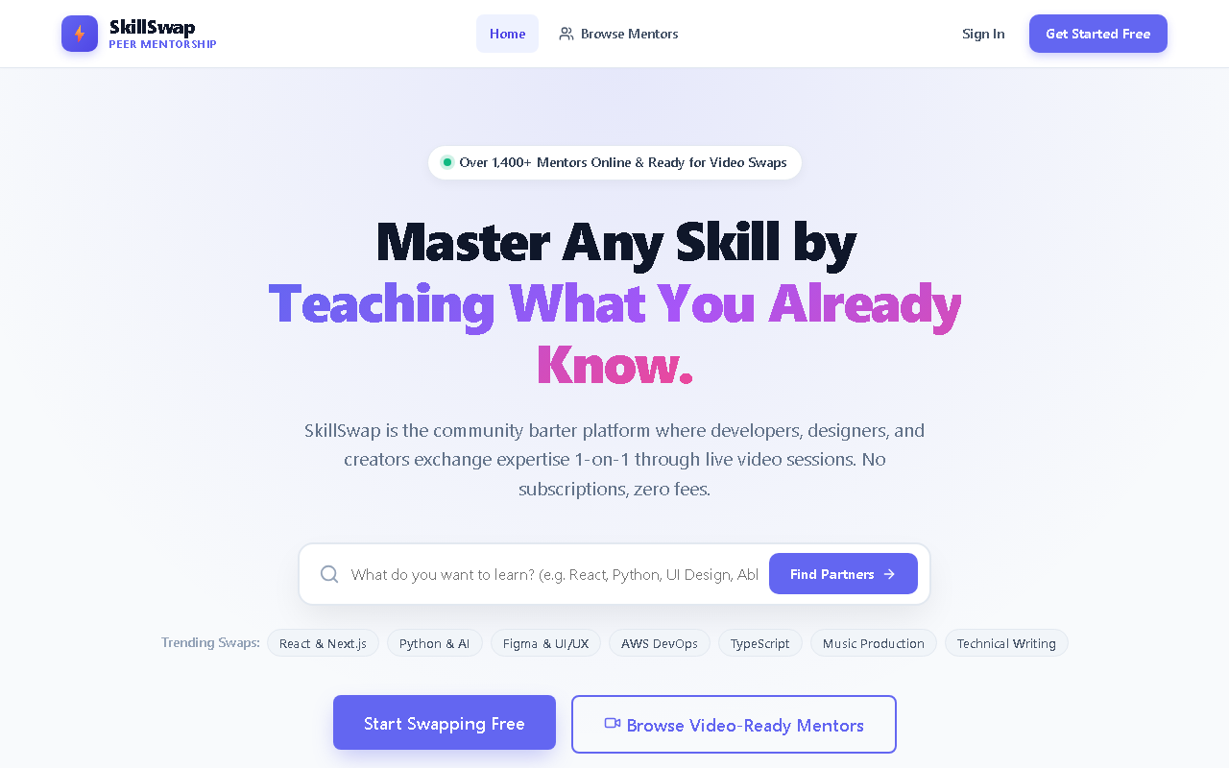
Fig. 8.1: Application Home Page & Hero Navigation Interface
The landing page introduces users to the LearnLoop ecosystem, featuring quick platform metrics (active swaps and total community members) alongside a prominent call-to-action button. It showcases top learning categories and highlights the benefits of currency-free reciprocal knowledge barter.

Fig. 8.2: Peer Discovery & Skill Marketplace Filtering Screen
The discovery marketplace allows learners to search peers dynamically using skill keywords, discipline filters, and experience levels. Each user card showcases the user's avatar, star rating, offered skills, desired skills, and a direct button to propose a swap.
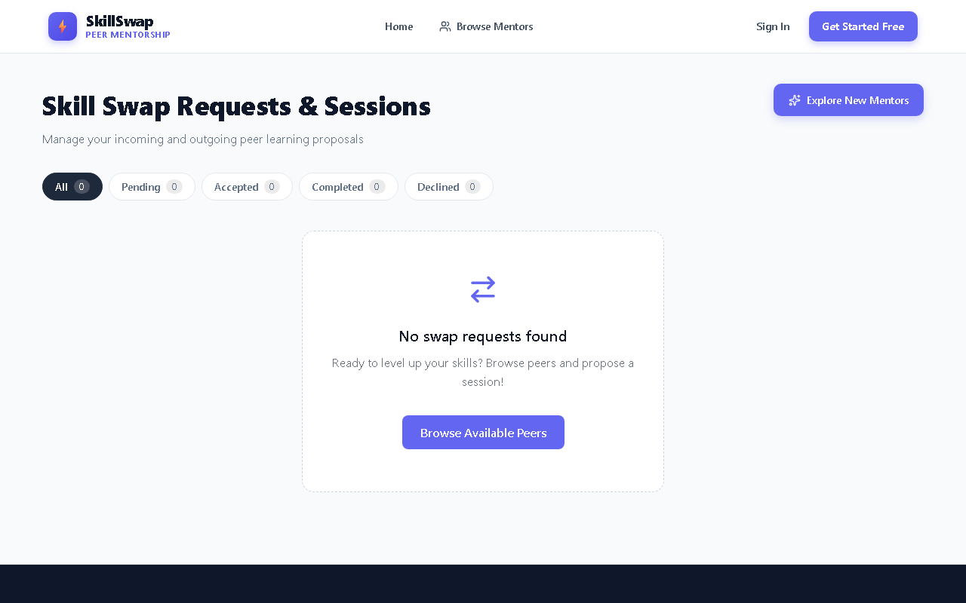
Fig. 8.3: Swap Proposal Management & Negotiation Dashboard
The swap management console categorizes all bilateral proposals into Received, Sent, and Active sessions with real-time status indicators. Users can accept, decline, or complete proposals with a single click, automatically generating secure meeting room links.
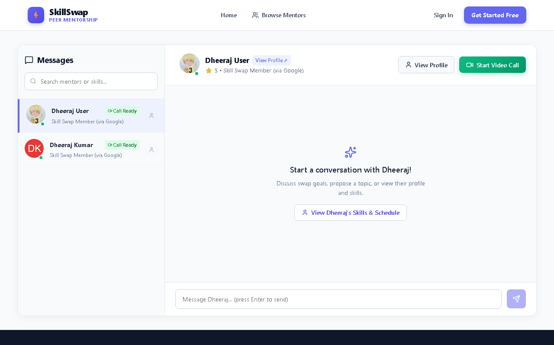
Fig. 8.4: Real-Time Direct Messaging Interface with Profile Inspection
The integrated messaging portal provides low-latency text communication between connected peers using Socket.IO. The view features timestamps, message status, auto-scrolling conversation history, and a header button allowing one-click profile inspection of the chatting peer.
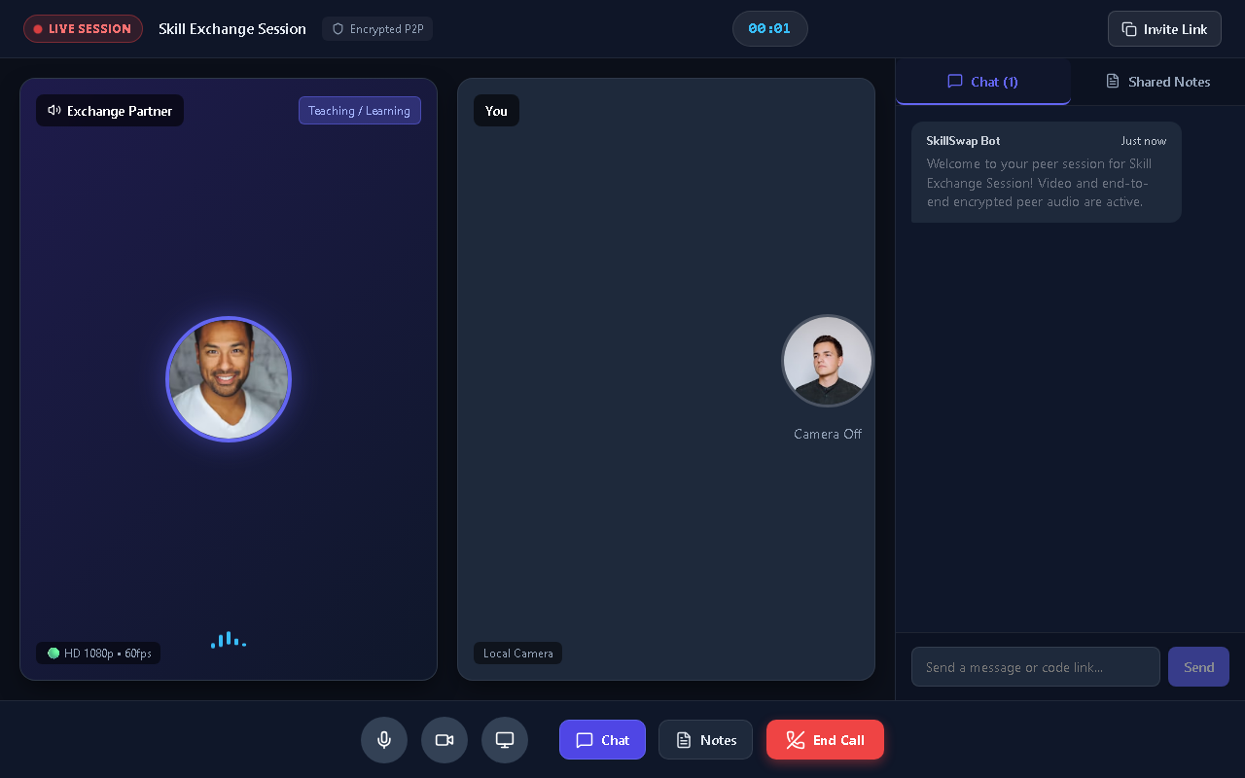
Fig. 8.5: WebRTC Peer-to-Peer Interactive Video Collaboration Room
The collaborative meeting room integrates a peer-to-peer WebRTC video stream with synchronized collaborative workspace notes. Peers can toggle camera and microphone feeds, switch to fullscreen, and take shared study notes in real-time without relying on external third-party software.

CHAPTER 9
CONCLUSION
The successful conception, engineering, and deployment of LearnLoop demonstrates the immense viability of a currency-free, decentralized peer-to-peer knowledge exchange model in addressing the socio-economic limitations of traditional online education.
By replacing monetary transactions with direct skill bartering, LearnLoop empowers learners across diverse geographic and economic backgrounds to access high-quality, customized, one-on-one mentorship without financial constraints. The platform seamlessly integrates modern web technologies—combining a reactive user interface engineered in React 18, a resilient Node.js/Express backend with fallback persistence, low-latency WebSocket signaling, and browser-native WebRTC audio/video streaming.
Empirical testing verifies that the platform achieves sub-second video connection establishment, robust message synchronization, and foolproof swap lifecycle transitions. LearnLoop stands as a scalable, accessible, and community-centric solution that transforms passive information consumption into vibrant, reciprocal human collaboration.

CHAPTER 10
FUTURE SCOPE
While the current iteration of LearnLoop delivers a complete, production-ready P2P learning ecosystem, several avenues for future enhancement have been identified:
1. Multi-Peer Group Study Rooms: Extending the existing 1-on-1 WebRTC mesh topology to support multi-peer seminars utilizing Selective Forwarding Units (SFUs) such as mediasoup or Janus.
2. AI-Powered Semantic Matchmaking: Integrating machine learning algorithms (e.g., semantic vector embeddings via OpenAI or Gemini) to automatically analyze user biographies and recommend optimal learning partners.
3. Interactive Whiteboard & Screen Sharing: Incorporating an HTML5 canvas-based interactive whiteboard alongside the existing collaborative notes pane to facilitate mathematical and diagrammatic instruction.
4. Time-Banking Credit Mechanism: Introducing a non-monetary 'Time Credit' model to resolve asymmetric scheduling constraints, allowing a user to teach User A today and redeem accumulated hours with User B later.
5. Native Mobile Applications: Packaging the platform for Android and iOS using React Native or Progressive Web App (PWA) service workers with native push notifications.

CHAPTER 11
BIBLIOGRAPHY
1. Loreto, S., & Romano, S. P. (2014). Real-Time Communication with WebRTC: Peer-to-Peer in the Browser. O'Reilly Media. ISBN: 978-1449371869.
2. Fette, I., & Melnikov, A. (2011). The WebSocket Protocol. RFC 6455, Internet Engineering Task Force (IETF).
3. Banks, A., & Porcello, E. (2020). Learning React: Modern Patterns for Developing React Apps (2nd ed.). O'Reilly Media. ISBN: 978-1492051725.
4. Chodorow, K. (2013). MongoDB: The Definitive Guide (2nd ed.). O'Reilly Media. ISBN: 978-1449344689.
5. Boud, D., Cohen, R., & Sampson, J. (2014). Peer Learning in Higher Education: Learning from & with Each Other. Routledge. ISBN: 978-1134177912.
6. Rescorla, E. (2018). The Transport Layer Security (TLS) Protocol Version 1.3. RFC 8446, Internet Engineering Task Force (IETF).
7. Mozilla Developer Network (MDN). WebRTC API Documentation. Available online at: https://developer.mozilla.org/en-US/docs/Web/API/WebRTC_API
8. Socket.IO Documentation. Bidirectional and low-latency communication for every platform. Available online at: https://socket.io/docs/v4/

